Non-Coding Regulatory Variants in Breast Cancer: Current Prediction Models and Experimental Gaps
Ravi Kumar KR^{1,2,3*}, Rakshitha M², Aditya BR², Spoorthi¹, Rakesh KS^{1,2}

¹DSIR Approved Research and Development Centre, Robust Materials Technologies Pvt Ltd, NGEF Layout, Nagarabhavi, Bangalore - 560 072 Karnataka, India
²VR Institute of Chemical, Biological & Information Technology Science, Sri Krishna Complex, 7th Main Road, Bharat Nagar, Bangalore - 560 091 Karnataka, India
³Simposys Healthcare LLP, 3rd Floor, Thirumala Complex, No.94, NGEF Layout, Naagarabhavi, Bengaluru - 560072 Karnataka, India

*Address for Corresponding Author
Dr. K.R. Ravi Kumar
Director & CEO
DSIR Approved Research and Development Centre,
Robust Materials Technologies Pvt Ltd., NGEF Layout, Nagarabhavi,
Bangalore - 560 072.
Karnataka, India.
e-mail: env1@robustmaterials.com
ravikumar.kr@robustmaterials.com
Phone No. 080 - 2318 6230

Abstract:
Most of the breast cancer risk loci discovered through genome-wide association studies are found in non-coding genomic regions. In such regions, they play a vital role in modulating gene expression. However, they do not affect protein-coding regions. This has been a major concern since most of the risk loci are found in non-coding regions. Even though fine-mapping techniques have been improved, and deep learning-based prediction models have been developed, accurately distinguishing between functional regulatory driver variants and non-functional passenger variants within linkage disequilibrium regions remains a major concern. Recent studies have developed several computational models based on motif-based, ensemble, and transformer-based models. Even though such models have improved prioritizing candidate variants, most of these models are limited by considering only linear sequence-based features. Moreover, none of the models have integrated genomic features sufficiently. For example, none of the models have considered three-dimensional chromatin structures, long-range enhancer-promoter interactions, or cancer subtype-specific epigenomic profiles. This has limited the precise mapping of functional regulatory variants to target genes. Moreover, experimental approaches, even though improved, are limited by the need to validate a large number of candidate variants. This review aims to discuss existing gaps in current computational prediction models and experimental approaches in identifying non-coding regulatory variants in breast cancer. Moreover, it emphasizes the need to develop integrative multi-layer models considering genomic, epigenomic, and structural features.
Keywords: Non-coding regulatory variants, Breast cancer, Enhancer–promoter interactions, Chromatin architecture, Transcription factor binding, Deep learning.
1.Introduction
Breast cancer GWAS have identified numerous susceptibility loci, but the majority of credible causal variants are non-coding rather than protein-coding gene variants [1] . Recent integrative genomic studies have demonstrated that breast cancer susceptibility variants are often present in enhancer, promoter, and transcription factor binding regions, where they can modulate gene expression through effects on chromatin accessibility and transcription factor activity [2]. Recent studies on long-range chromatin interaction have demonstrated that breast cancer susceptibility variants can modulate the activity of distant oncogenes through enhancer-promoter chromatin looping rather than through effects on the closest gene, thus redefining the conventional mapping of susceptibility variants and breast cancer risk genes [3] . Non-coding mutations affecting breast cancer susceptibility have been found to converge on several gene regulatory pathways, including those regulating the expression of the oncogene ESR1, thus emphasizing the role of enhancer pathways in breast cancer development [4] .
Despite these developments, however, it is still a major challenge to precisely discriminate between actual functional regulatory drivers and passenger variation sites present within linkage disequilibrium blocks. Current computational models, such as those based on motifs, ensemble scoring, and even deep learning-based approaches, though helpful for prioritizing these sites, often fail to integrate three-dimensional chromatin structures and subtype-specific epigenetic information [5] [6] [7]. Although new long-range sequence model developments attempt to account for distal regulatory effects, integration of chromatin structures and transcriptional network effects is limited [8]. Additionally, different molecular subtypes of breast cancer, such as ER-positive and triple-negative subtypes, have different enhancer landscapes and regulatory programs, making it essential for predictive modeling approaches to account for these effects [9].

Objective of this study
The objective of this study is to systematically investigate the role of non-coding regulatory variants in the development and progression of breast cancer, with special emphasis on the regulation of the gene regulatory network. The study will explore the functional consequences of inherited and somatic mutations in enhancers, promoters, long non-coding RNAs, and structural DNA regions, and how these variations affect transcription factor binding, chromatin structure, and the regulation of the associated downstream targets. The study will also aim to solve the long-standing problem of how to distinguish causal regulatory variants from associated passenger variants within fine-mapped GWAS loci, especially in complex regions with high linkage disequilibrium and long-range chromatin interactions.
The study will also investigate the limitations of the current computational prediction models, and how the integration of multi-layered genomic information, such as sequence, epigenomic, and three-dimensional chromatin structure, and subtype-specific transcriptional information, may help to solve this problem and enhance the accuracy of the prediction models, especially with regard to the regulation of the estrogen receptor signaling pathway, which plays a key role in the development and progression of breast cancer. The study will also investigate the possibility of using the emerging deep learning and transformer models to enhance the context-aware regulatory prediction models, which will be more interpretable and amenable to experimental validation.
To address these objectives, the study is guided by the following research questions:
- How can true regulatory driver variants be distinguished from passenger non-coding variants within breast cancer GWAS loci?
- How can 3D chromatin architecture be integrated into predictive models for enhancer–promoter assignment?
- How can prediction models capture breast cancer subtype-specific regulatory landscapes?
- What scalable experimental strategies can validate predicted regulatory variants?
- How can deep learning models be made mechanistically interpretable for regulatory variant analysis?
Problem Statement:
Although several risk loci have been identified for breast cancer through GWAS, the majority of credible driver variants lie in non-coding regions, whose functional significance is still not well understood. Current fine-mapping and prediction tools are not able to sufficiently differentiate true driver variants from passenger effects within the block of linkage disequilibrium. Current computational tools are limited, as they are based on sequence-level features, failing to integrate 3D chromatin structures, subtype-specific epigenomic features, and dynamic transcriptional networks. Experimental validation is also limited, as current tools are low-throughput compared to the number of predicted driver variants. Thus, there is an urgent need for an integrated multi-layer framework to identify and functionally validate non-coding regulatory drivers in breast cancer.
2.Materials & Methods:
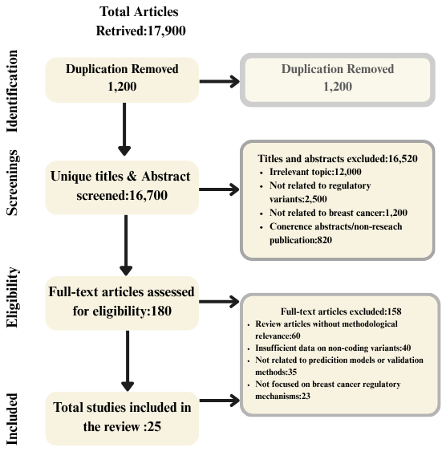
Figure 1: Materials & Methodology
The aim of this study was to conduct a comprehensive literature review to examine the role of non-coding regulatory variants in breast cancer and to evaluate current computational prediction models alongside experimental validation strategies. In particular, the study focused on understanding how regulatory variants influence gene expression, how predictive models identify functional regulatory drivers, and how experimental methods validate these variants. The working methodology of the literature selection process is illustrated in Fig. 6. The review primarily focused on original research articles that investigate regulatory variants, chromatin architecture, transcription factor binding, and computational prediction frameworks related to breast cancer.
The review process targeted recent research studies published mainly from 2017 to 2025, with several earlier foundational studies included to provide background knowledge and methodological context. Keywords used during the literature search included non-coding regulatory variants, breast cancer GWAS, enhancer–promoter interactions, chromatin architecture, regulatory variant prediction models, deep learning in genomics, CRISPR validation, and transcription factor binding variants. These keywords were used to retrieve relevant studies primarily from Google Scholar, ensuring broad coverage of interdisciplinary genomic and computational biology research.

Inclusion Criteria
The inclusion criteria for selecting studies in this review were as follows:
• Research articles investigating non-coding regulatory variants associated with breast cancer risk or progression.
• Studies that analyze genomic regulatory mechanisms such as enhancers, promoters, transcription factor binding sites, chromatin architecture, and non-coding RNAs.
• Papers proposing or evaluating computational prediction models, including machine learning or deep learning frameworks for regulatory variant analysis.
• Experimental studies using CRISPR-based perturbation, reporter assays, or chromatin interaction mapping to validate functional regulatory variants.
• Empirical studies examining variant-to-gene regulatory relationships, transcriptional network changes, or subtype-specific regulatory mechanisms in breast cancer.

Exclusion Criteria
The exclusion criteria for this review were as follows:
• Studies not related to breast cancer regulatory genomics or non-coding variants.
• Articles focusing exclusively on protein-coding mutations without regulatory genomic context.
• Papers that do not provide functional interpretation, computational modeling, or experimental validation of regulatory variants.
• Publications such as conference abstracts, editorial notes, or non-peer-reviewed reports lacking sufficient methodological or experimental detail.
• Studies focusing on general cancer genomics without specific relevance to regulatory mechanisms in breast cancer.

Quality Assessment and Screening Process
To ensure the selection of high-quality and relevant scientific literature, the search process focused on reputable academic sources indexed through Google Scholar. The initial search retrieved approximately 17,900 publications related to regulatory genomics, breast cancer variants, and computational prediction models. After removing 1,200 duplicate records, 16,700 unique titles and abstracts were screened for relevance.
During the screening phase, 16,520 articles were excluded based on irrelevance to the study focus, lack of regulatory variant analysis, or publication type restrictions. As a result, 180 full-text articles were assessed for eligibility through detailed evaluation of their methodology, experimental design, and relevance to non-coding regulatory variant research.
Further critical assessment led to the exclusion of 158 studies due to insufficient methodological relevance, lack of focus on regulatory mechanisms, or absence of experimental or computational analysis related to breast cancer. After completing the screening and eligibility assessment stages, 22 research articles were finally selected and included in the review.This systematic review process ensured that only high-quality and scientifically relevant studies were included, allowing a comprehensive evaluation of current approaches for predicting and validating regulatory variants in breast cancer.
3.Literature Survey:
3.1 How can true regulatory driver variants be distinguished from passenger non-coding variants within breast cancer GWAS loci?
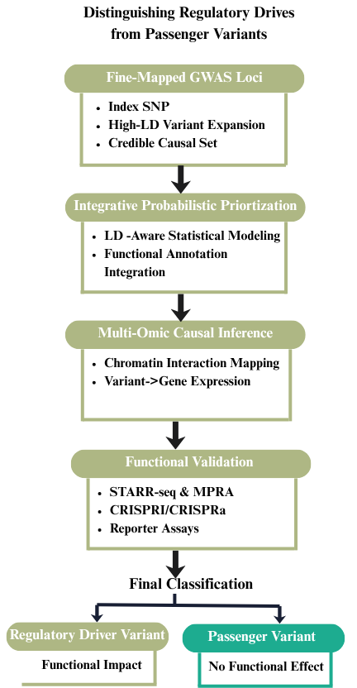
Figure 2: Multi-layer framework for distinguishing regulatory driver variants from passenger non-coding variants in breast cancer GWAS loci.
Figure 2: The figure illustrates a structured framework for differentiating actual regulatory driver variants from non-coding passenger variants in breast cancer GWAS loci. The process begins with GWAS loci that have undergone fine-mapping. In this step, the index SNPs identified in the GWAS loci are converted to high linkage disequilibrium sets. The identified variants are then filtered using integrative probabilistic models. The variants are then associated with genes using multiple omics causal inference layers. Chromatin interaction mapping and gene expression integration provide evidence for the functional relationship between variants and genes. Finally, high-throughput functional validation experiments like STARR-seq, MPRA, and CRISPR-based perturbation experiments classify the variants as functional driver variants or non-functional passenger variants.
3.1.1 Integrative Probabilistic Fine-Mapping Models for Regulatory Driver Identification
Integrative probabilistic fine-mapping models focus on true functional regulatory driver variants in breast cancer GWAS loci by considering both linkage disequilibrium and multi-layer functional data. Statistical approaches in expanding GWAS index SNPs into high linkage disequilibrium sets enable the evaluation of candidate variants in functional regulatory regions, minimizing biases from genotyping arrays [1]. Functional annotation models, such as those using DNase hypersensitivity, histone modification, transcription factor binding, and eQTL enrichment, increase the probability of true functional regulatory variants, excluding false positive variants resulting from linkage disequilibrium [1] [2]. Prioritization models using computational tools also consider conservation, motif disrupting and gaining, enhancer-gene association, and recurrence in prioritizing true functional variants in breast cancer GWAS loci, providing probabilistic scores for non-coding variants [3] [2]. Integrative functional models using somatic and non-coding variants, mutation-associated gene expression, and clinical outcomes provide more robust functional interpretation by showing the downstream effects of true functional variants [4] . High-throughput functional assays, such as STARR-seq, also provide quantitative measurements of allele-specific regulatory activities, enabling the direct differentiation of true functional regulatory variants from false positive variants in GWAS loci [3].

3.1.2 Multi-Omic Causal Inference Frameworks Combining Epigenomics and Gene Expression

The multi-omic causal inference models enable the identification of functional regulatory variants based on the integration of genetic fine-mapping with epigenomic annotations and gene expression to determine mechanistic links between variants and genes. Colocalization analysis between causal variants and eQTL signals has shown that there are instances in which different risk loci harbor the same causal variant that regulates both the risk and gene expression [5].Chromatin state and transcription factor binding assays have shown that different risk variants can influence gene expression by regulating the activity of enhancers or the binding affinity of transcription factors [6] [7]. Variant → Chromatin → Target Gene models that incorporate Capture Hi-C analysis have shown that there are instances in which different risk variants can influence gene expression through long-range looping events that link candidate non-coding RNA or protein-coding genes [5].Functional perturbation assays have shown cross-validation that different recurrent functional regulatory mutations significantly affect promoter activity [8] .These findings support mediation models in which different genetic variants can influence gene expression by remodeling the chromatin landscape and transcription factors in different subtypes of breast cancer [9].

3.2 How can 3D chromatin architecture be integrated into predictive models for enhancer–promoter assignment?

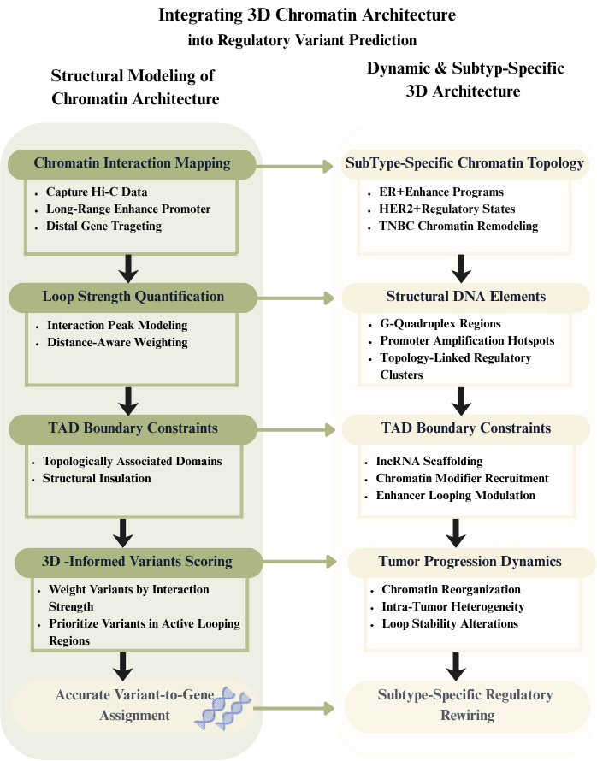

Figure 3: Integration of structural and dynamic three-dimensional chromatin architecture into enhancer–promoter assignment and regulatory variant prediction in breast cancer.

Figure 3: The figure illustrates the dual-layer model, showing the integration of 3D chromatin architecture into regulatory variant prediction models. The left side of the figure represents the structural modeling, where chromatin interaction mapping, quantitative loop scoring, and integration of TAD boundary constraints are mentioned. This allows 3D-informed regulatory variant prioritization, which improves the accurate mapping of regulatory variants to genes, moving beyond genomic proximity. On the other hand, the right side of the figure represents the dynamic chromatin architecture, showing the subtype-specific chromatin organization, where the chromatin architecture of ER-positive, HER2-positive, and triple-negative breast cancer subtypes is shown, including structural DNA elements, RNA-mediated genome organization, and tumor progression-induced chromatin reorganization.

3.2.1 Quantitative Modeling of Chromatin Looping and TAD Structure in Variant Prioritization

Quantitatively integrating three-dimensional chromatin structure can be achieved in models of enhancer-promoter pair assignments by directly integrating high-resolution chromatin interaction data in variant prioritization pipelines. Using capture Hi-C data, non-coding risk variants have been shown to physically interact with protein-coding genes and lncRNAs at a distance of up to several megabases, thus redefining the scope of their regulatory targets beyond those in linear proximity [10]. Statistical modeling of interaction peaks using distance-aware negative binomial models can be used to quantify the strength of interaction peaks and thus incorporate this information as weighted evidence in models of enhancer-promoter pair assignments, thus allowing non-coding risk variants in more interactive bait regions to be assigned higher scores as functional regulatory drivers [10].More recent predictive models based on transformer architectures can be used to model the effects of mutations on gene regulation across megabase-sized genomic regions and have shown that learning long-range effects can be achieved by preserving distal genomic context [11].By integrating this information with gene expression prediction, non-coding functional drivers can be more accurately distinguished from hotspot-based models, thus reinforcing the importance of three-dimensional context in gene regulation [11] .In addition, using TAD boundary information as constraints in models of gene regulation can refine predictions by restricting assignments to topologically insulated domains, as supported by experimental data on looping interactions in breast cancer susceptibility regions [10].

3.2.2 Dynamic and Subtype-Specific 3D Genome Architecture in Breast Cancer

Dynamic and subtype-specific three-dimensional genome organization in breast cancer involves changes in regulatory chromatin states, structural DNA elements, and non-coding RNA networks. Comparative integrative analysis reveals that changes in regulatory elements and non-coding RNA networks vary among ER-positive, HER2-positive, and triple-negative breast cancer subtypes. Such changes have been found to reshape the enhancer and chromatin states specifically for each subtype [12] . Genome-wide mapping of G-quadruplex (G4) DNA structures in patient-derived tumor xenografts reveals subtype-specific structural landscapes and molecular tumor classification into G4-enriched tumor subtypes. The ∆G4 regions have been found to be enriched at subtype-specific amplified promoters and subtype-specific transcription factor programs [13] .Such changes have been found to be associated with triple-negative states and integrative cluster transitions, revealing the reorganization of the genome with tumor progression and heterogeneity [13] .Non-coding RNA networks have been found to influence the organization of the genome by the transfer of regulatory RNA from one cell to another via extracellular vesicles, which can potentially influence the subtype-specific chromatin states and the stability of the variant-specific enhancer-promoter looping configurations [14] .

3.3 How can prediction models capture breast cancer subtype-specific regulatory landscapes?

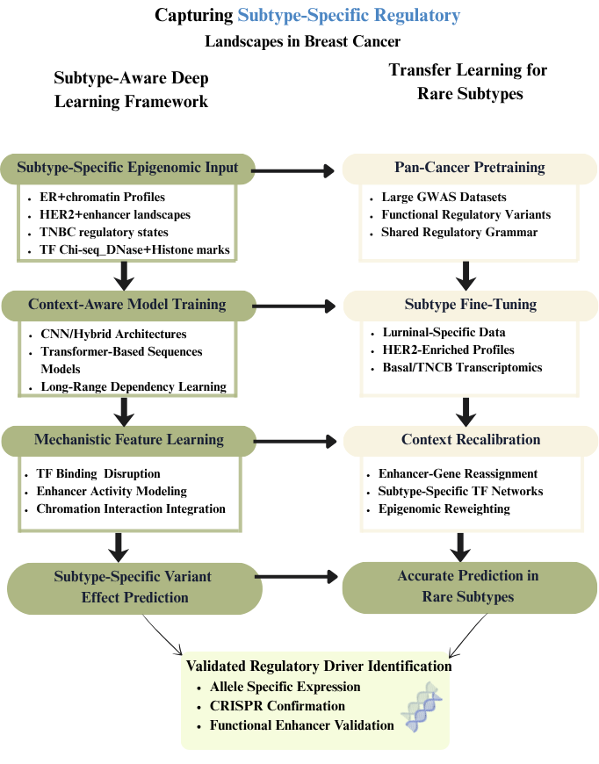
Figure 4: Computational framework for subtype-aware and transfer learning–based modeling of regulatory variants in breast cancer.
Figure 4: The figure illustrates a dual strategy-based model for understanding subtype-specific regulatory landscapes in breast cancer with the help of highly advanced computational modeling tools. The left panel depicts a subtype-aware deep learning model in which the model is trained on ER+, HER2+, and TNBC subtype-specific epigenomic profiles to learn subtype-specific transcription factor binding patterns, enhancer activity, and long-range chromatin interactions. The right panel depicts a transfer learning-based model in which the model is pre-trained on highly extensive regulatory landscapes in different cancers to address the problem of limited sample availability in rare subtypes. The context recalibration step helps in refining enhancer-gene associations as well as transcription factor networks to optimize predictive specificity. Finally, both approaches converge to experimentally validate regulatory driver discovery with the help of allele-specific expression analysis as well as CRISPR-based functional validation.

3.3.1 Subtype-Aware Deep Learning Models Trained on Breast Cancer–Specific Epigenomi Data

Subtype-specific regulatory landscapes can be represented using deep learning models that are trained on epigenomic data sets defined in terms of particular cellular contexts, in which chromatin accessibility, histone marks, and TF-binding characteristics are reflective of ER+, HER2+, or TNBC subtype-specific regulatory programs. Gene-expression models based on subtype-specific transcription factor binding events have shown that models that incorporate cell line-specific TF ChIP-seq peaks, DNase hypersensitivity, and chromatin interaction data can predict quantitative effects of cis-regulatory regions and can be extended to subtype-specific modeling of enhancers [15] .Deep learning models in non-coding variant effect prediction have shown that convolutional and hybrid models can predict effects of non-coding variants on chromatin marks and TF binding in a cell-type-specific manner and can be extended to subtype-specific modeling [16] .In this regard, subtype-specific modeling can be extended using regulome predictors based on DNABERT models, which have shown improved contextual representation of short genomic variants by learning long-range dependencies in DNA sequences, which can be particularly important in modeling subtype-specific enhancer-promoter interactions [17].Simultaneously, context-free and context-dependent modeling using a statistically weighted ensemble of different regulatory scoring systems can be particularly useful in refining subtype-specific regulome predictions by using subtype-matched regulatory variants [18]. Overall, subtype-specific modeling using epigenomic data sets, mechanistic modeling based on TF binding, context-aware modeling using transformer models, and context-dependent modeling using ensemble models can provide a robust approach to modeling subtype-specific regulome landscapes in breast cancer while accurately separating functional regulatory variants from non-functional background signals.

3.3.2 Transfer Learning and Domain Adaptation for Rare Breast Cancer Subtypes

The scarce resources of rare subtypes of breast cancer can be overcome with the help of different strategies of transfer learning that can make use of the large resources of pan-cancer data on regulatory variants to pretrain models before refining them on scarce subtype resources. Systematic high-throughput functional screening of thousands of cancer-associated GWAS loci can yield a large number of experimentally validated regulatory variants that are enriched in enhancer marks, transcription factor binding sites, and eQTL signals and can provide a robust pan-cancer resource for model pretraining [3] .Integrative analyses of the association of coding and non-coding variants with gene expression and molecular subtype outcomes can further show that the effects of different regulatory variants vary in luminal, HER2-enriched, and basal-like breast cancer subtypes and therefore require domain adaptation to refine the models [4]. Refining the models on subtype-stratified transcriptomic and epigenomic resources can recalibrate the associations of enhancers with genes in different context-dependent regulatory environments [4] . Cross-validation with functional assays can increase the robustness of the models by showing that the predicted functional variants are functional and exert endogenous transcriptional effects [3] .
3.4 What scalable experimental strategies can validate predicted regulatory variants?
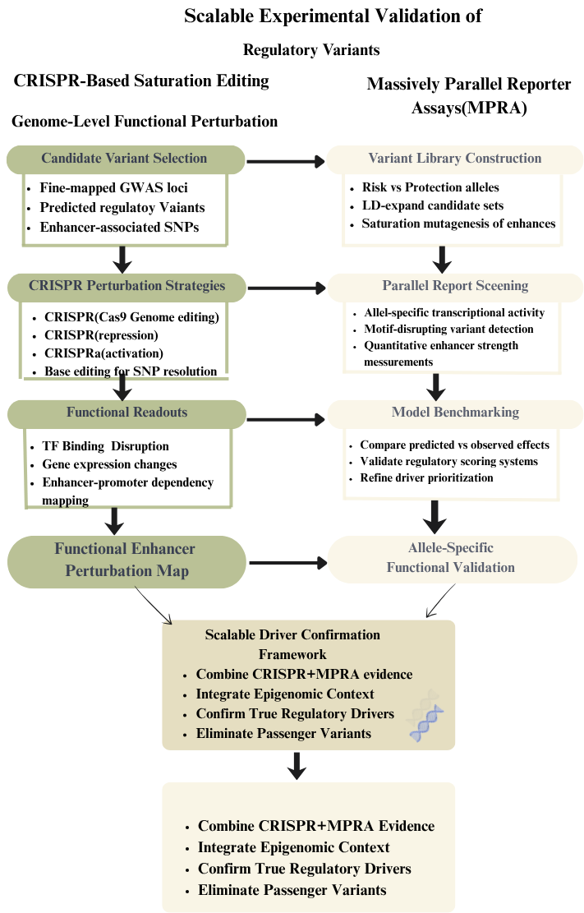

Figure 5. Scalable CRISPR- and MPRA-based experimental framework for functional validation of predicted regulatory variants in breast cancer.

Figure 5: The figure illustrates a scalable experimental validation approach that can be used to verify the predicted variants in breast cancer development. In the left panel, there is a representation of high-throughput CRISPR-based saturation editing, in which functional analysis of GWAS variants that have been precisely mapped is carried out using CRISPR/Cas9, CRISPRi, CRISPRa, and base editing techniques. On the other hand, in the right panel, there is a representation of massively parallel reporter assays (MPRA), which can be used to simultaneously test thousands of candidate variants to assess their enhancer strength and validate computational predictions. By integrating the CRISPR and MPRA approaches, a robust approach can be established to functionally distinguish between driver and non-driver variants in cancer development.

3.4.1 High-Throughput CRISPR-Based Saturation Editing of Regulatory Elements

Scalable validation of the functional impact of predicted regulatory variants can be achieved by employing high-throughput CRISPR-based perturbation platforms that can functionally validate enhancer elements at the nucleotide level. Functional screening platforms that integrate reporter assays with CRISPR-based perturbation studies have provided evidence that prioritized breast cancer susceptibility variants have a functional impact on enhancer elements and associated gene expression. Such functional validation studies have enabled the parallel validation of multiple candidate variants [19]. CRISPR/Cas9-based genome editing with ChIP-qPCR and expression analysis has provided evidence that allele-specific disruption of transcription factor binding to enhancers can be used to validate the functional impact of non-coding regulatory variants. Such functional validation studies have provided evidence that allele-specific disruption of transcription factor binding to enhancers can be used to validate the functional impact of non-coding regulatory variants at the SNP level [20] .Recurrent non-coding regulatory mutations identified in tumor genomes can be functionally validated using genome editing-based approaches to elucidate enhancer-promoter interactions [8].Functional validation of candidate enhancer elements can be achieved by combining CRISPRi and CRISPRa screening platforms to generate functional enhancer perturbation maps that distinguish functional regulatory elements from non-functional variants [19] .In conclusion, saturation editing-based functional validation studies have provided evidence that can be used to validate the functional impact of predicted regulatory drivers in breast cancer.

3.4.2 Massively Parallel Reporter Assays (MPRA) for Systematic Functional Annotation

The use of massively parallel reporter assays allows for the functional annotation of non-coding variants by determining allele-specific enhancer activities in thousands of candidate sequences in a single study. High-throughput functional screening of breast cancer susceptibility loci shows that candidate regulatory variants in open chromatin regions can be cloned and assayed in parallel to determine differential transcriptional activities between risk and protective alleles [19] .Computational models can be used to refine the design of MPRA studies by prioritizing candidate variants in linkage disequilibrium with index variants identified in genome-wide association studies, restricting analysis to topologically associated domains, and integrating evidence of eQTL and allele-specific gene expression [21] .Saturation mutagenesis of candidate enhancer regions surrounding prioritized candidate variants can be used to functionally test nucleotide substitutions in enhancer regions to determine variants that disrupt or create transcription factor motifs and significantly affect transcription factor binding and promoter activation [21] .The quantitative allele-specific activities determined in MPRA studies can be used to develop standards for functional prediction models by comparing predicted scores with observed transcriptional activities [19].The integration of MPRA activity maps with epigenomic annotations and genome-wide association study signals can be used to develop a scalable validation approach to distinguish functional variants from nonfunctional variants in breast cancer susceptibility loci.
3.5 How can deep learning models be made mechanistically interpretable for regulatory variant analysis?
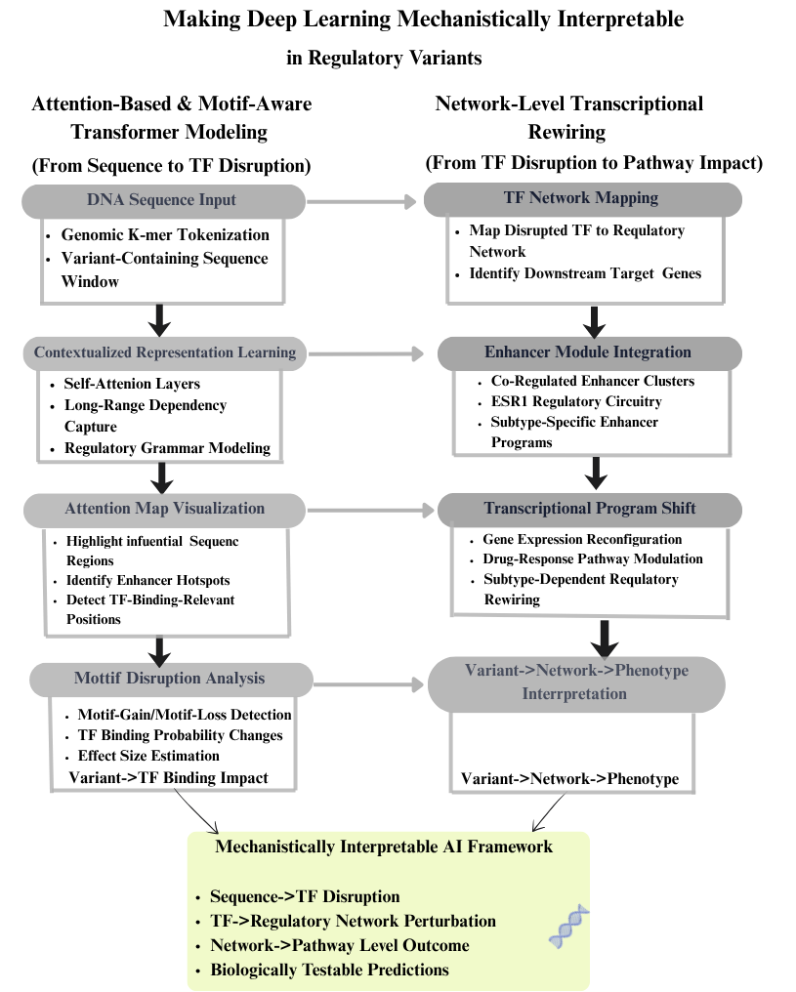
Figure 6. Interpretable deep learning framework linking sequence-level variant effects to transcription factor disruption and network-level regulatory rewiring in breast cancer.
Figure 6: The figure illustrates a two-layer framework for making deep learning models mechanistically interpretable in regulatory variant analysis. The left panel of the figure illustrates how attention-based and motif-aware transformer architectures are applied for processing DNA sequences containing variants and for capturing long-range regulatory dependencies, visualizing regions of interest using attention-based mapping, and measuring disruption of TF binding. The right panel of the figure illustrates how this approach is extended for network-level modeling, including disrupted TFs and enhancer modules and transcriptional regulatory networks for assessing changes in gene expression and downstream phenotypic consequences.
3.5.1 Attention-Based and Motif-Aware Transformer Models for TF Disruption Analysis
Attention-based and motif-aware transformer models improve mechanistic interpretability in Regulatory variant analysis, as DNA sequences are represented as contextualized embeddings, which can capture long-range dependencies and transcription factor grammars. The DNABERT model and similar models tokenize DNA sequences into k-mers and use self-attention mechanisms to recognize regulatory patterns, which can also be visualized using attention weights, thus providing information about the most influential regions in DNA sequences for RV variant effect prediction [18] .Deep learning models, such as convolutional and hybrid models, trained using large-scale epigenomic data also show promise in recovering known transcription factor binding motifs and measuring the strength of predicted binding probabilities, even in the presence of nucleotide substitution [16] . Mechanistic gene-expression models, which involve alterations in transcription factor binding, directly translate DNA sequences into predicted gene-expression changes, thus providing variant-level interpretation using effect size estimation and linkage disequilibrium resolution [15]. The combination of attention weight visualization and predicted transcription factor binding score differences can also help in identifying disrupting variants in enhancer regions, thus providing direct mapping from DNA sequence alterations to gene-expression regulation [18] [15].Such interpretable models based on transformer models bridge the gap between black-box prediction and mechanistic interpretation, providing insights into the effects of specific non-coding region variants in disrupting transcription factor binding and gene regulation.

3.5.2 Network-Level Modeling of Variant-Induced Transcriptional Rewiring

This requires the integration of non-coding sequence variations into transcription factor interaction networks and modules of enhancers. This can be accomplished through integrative mechanistic frameworks, which have demonstrated the ability of non-coding sequence variations to be mapped onto specific transcription factors, which can modulate downstream pathways of gene expression. This has been demonstrated to establish the ability of sequence variations to modulate pathway-level phenotypes of drug response. [7] .Comprehensive analysis of alterations in cis-regulatory elements and long non-coding RNA dysregulation demonstrates the ability of enhancer alterations to propagate through modules of co-ordinated transcription, thus reconfiguring the subtype-specific regulatory network in breast cancer [14].Experimental validation of the role of non-coding sequence variations through CRIPSR-mediated enhancer deletion and reporter assays demonstrates the ability of the disruption of specific enhancer nodes to modulate the expression of co-regulated targets, thus validating the concept of enhancer module dependency [9] .Non-coding sequence variation-induced perturbations can be mapped onto the transcription factor-gene interaction network, thus facilitating the functional understanding of the role of non-coding sequence alterations in reconfiguring oncogenic pathways. [7] .

4.1 Research Findings

4.1.1 Identification of Regulatory Drivers in Non-Coding Regions

However, a growing body of evidence suggests that the vast majority of breast cancer susceptibility variants identified by genome-wide association studies are found in non-coding regulatory regions of the genome and not in protein-coding exons of genes. The results of fine-mapping and integrative annotation approaches have shown that credible causal variants are enriched in enhancers, promoters, and DNase hypersensitive regions, especially in estrogen receptor-positive contexts [22] .Capture Hi-C and integrative genomic approaches have also shown that such variants often regulate distal oncogenes via enhancer-promoter looping interactions and not via nearest gene relationships [10] .The observation of recurring mutations affecting enhancers regulating ESR1 also provides evidence that inherited as well as acquired non-coding mutations are regulatory drivers of breast cancer risk and progression [9] .

However, it is worth mentioning here that recurrence of mutations does not necessarily imply functionality; identification of drivers of cancer risk requires integration of different approaches such as TF occupancy, chromatin accessibility, and ASE experiments to demonstrate functionality of variants [6] .

“Most credible causal variants identified in breast cancer GWAS map to noncoding DNA and are thought to influence transcriptional regulation” [22].

4.1.2 Limitations of Current Prediction Approaches
The existing computational models for the prediction of regulatory variants are based on sequence motif disruption, conservation, and fine-mapping of GWAS variants using statistical methods. These models are effective in narrowing the list of variants but are often not useful in providing mechanistic insight into the regulation of chromatin context and long-range regulation [1] .The recent advances in deep learning models, such as convolutional neural networks and transformer models, have shown improvement in the prediction accuracy using regulatory grammar, which is learned directly from the DNA sequence. However, most models are restricted to one-dimensional models without the incorporation of chromatin context and epigenomic maps specific to breast cancer subtypes [16] .
Ensemble statistical learning models are another approach that aggregates the different scoring models to achieve better prediction, but these models often rely on general training datasets instead of epigenomic datasets from primary breast tissue [17] .These models indicate the limitations of the existing methods.
“While much work has been done, there is still much to do in translating GWAS findings into mechanistic understanding” [22] .

4.1.3 Incorporation of 3D Chromatin Architecture
Recent studies suggest that breast cancer susceptibility regions often regulate genes at distant sites, rather than those immediately adjacent, through spatial chromatin looping. Capture Hi-C studies have shown that these regions can skip over intervening genes and directly interact with distant promoters, thus redefining the way in which variants are mapped to potential target genes [10] .Integrated modeling of these types of cis-regulatory relationships further validates the concept of chromatin topology playing an integral role in the regulation of these regions, thus constraining these relationships within topologically associated domains (TADs) [21] .
Although these studies have been able to show the importance of chromatin topology in the regulation of these regions, most current prediction tools do not take into account the 3D organization of the genome, thus failing to provide complete enhancer-promoter relationships. Recent studies using Transformer-based long-range sequence models have been able to show the potential of these models in understanding the effects of distant mutations on gene expression, thus modeling the effects of these types of mutations on the genome at the megabase scale [11]. Thus, chromatin topology modeling is an essential step in the prediction of these types of relationships.
“Regulatory elements can act over distances of at least 1 Mb and frequently skip over nearby genes” [22].

4.1.4 Experimental Validation Bottlenecks
The growth of computational prioritization tools has been rapid, experimental validation of regulatory driver identification has been a major challenge. Reporter assay and enhancer activity measurement experiments have been used to validate the functional impact of the prioritized variants. However, these experiments have been found to be labor-intensive and limited in throughput [19].CRISPR/Cas9 enhancer deletion and targeted perturbation experiments have been used to validate the regulatory impact of certain enhancer clusters for the regulatory control of certain breast cancer drivers, such as ESR1. However, these experiments have been found to be locus-specific rather than genome-wide [9] .
The number of causal variants identified by fine-mapping, which can be as high as thousands, far exceeds the capacity for functional validation experiments. Additionally, functional validation experiments have been found to be conducted on breast cancer cell lines instead of normal cells, which may not be representative of the early risk mechanisms for breast cancer.
“Identifying target genes and causal variants robustly is likely to require multiple data types” [22] .

4.1.5 Toward a Unified Multi-Layer Regulatory Framework
Recent studies have highlighted that interpretation of regulatory variants should go beyond enhancer annotation to incorporate multi-layer regulatory modeling. G-quadruplex DNA structural regions have been identified as stratifying breast cancer subtypes and impacting transcriptional regulation. Such studies indicate that higher-order DNA structure can impact regulatory heterogeneity in breast cancer [13] .Long non-coding RNAs and regulatory changes in enhancers have been reported to modulate subtype-specific chromatin structure and transcriptional regulation [14] .
A unified model that incorporates statistics for fine-mapping variants, epigenomic analysis, chromatin conformation analysis, transcription analysis, and interpretable machine learning can be used to prioritize regulatory variants in a context-aware manner. Such an integrative model aligns with the recent consensus that statistical association must be complemented with functional analysis that can represent biological processes in disease.
“Combining statistical data from fine-scale mapping with functional data that are more representative of the normal ‘at risk’ breast should lead to a greater understanding of disease mechanism” [22] .

4.2 Possible Gaps

4.2.1 Ethical, Clinical, and Data Governance Considerations
However, the ethical and governance aspects have not been extensively explored in relation to breast cancer risk. Most fine-mapping and functional annotation studies have been conducted to establish statistical confidence and mechanistic inference, but not in terms of representation [22] . Most reference data sets from genome-wide association studies and epigenomic data sets have been found to have a high representation of people of European descent, which may limit the representation and application of models in relation to predictive models in different populations [22] .The application of gene regulation and gene expression has also been found to highlight the population-specific linkage disequilibrium, which is crucial in relation to breast cancer [4] .The application and interpretation of regulatory variant predictions in relation to breast cancer risk are complex and require careful interpretation, especially in relation to their application in clinical scenarios. The application and interpretation of enhancer mutations in relation to ESR1 gene regulation in breast cancer have been found to highlight the mechanistic role in relation to breast cancer [9] . The application and interpretation of such predictions in relation to breast cancer risk stratification require careful validation.
“The translation of GWAS findings into clinical practice requires careful interpretation and validation beyond statistical association” [22].

4.2.2 Standardization, Reproducibility, and Implementation Barriers
Regulatory Variant Prediction is marked by ‘methodological heterogeneity.’ This reduces the overall ‘reproducibility and comparability of different studies.’ Several computational tools, from ‘motif-based enrichment methods’ and ‘ensemble learning-based methods’ to ‘deep learning-based methods,’ use different ‘training datasets,’ ‘scoring functions,’ and ‘validation benchmarks.’ [17]. These methodological differences often lead to ‘inconsistent prioritization of putative variants across different studies.’ This is especially true for ‘cell-line-based epigenomic annotations.’
Moreover, ‘chromatin conformation datasets’ for ‘enhancer-promoter mapping’ are ‘variable.’ These differences lead to ‘differences in variant-to-gene mapping.’ [10]. ‘Experimental validation of putative variants’ is ‘currently highly fragmented.’ ‘Reporter assays,’ ‘CRISPR-based perturbation assays,’ and ‘chromatin interaction assays’ are ‘applied inconsistently and often at limited scale.’ [19].Such ‘fragmentation of validation approaches’ maintains ‘the gap between computational prioritization and biological validation.’
“Identifying functional variants and linking them to target genes remains a major challenge despite advances in fine-mapping” [22].

4.2.3 Need for Integrated Multi-Layer Modeling Frameworks
Current predictive models of functional variants often occur in isolated analytical layers, including disruption of sequence motifs, overlap with chromatin accessibility, colocalization with eQTLs, or chromatin looping analysis. Although all of these layers provide important information in their own right, compartmentalized modeling limits our ability to model the propagation of functional effects of variants on transcription factors and genome topology. Recent work in integrative genomic analysis has shown that variants in enhancer regions can affect gene expression in other locations through sets of coordinated functional regulatory elements, rather than isolated motifs [21]. Similarly, recent work on structural DNA elements and non-coding RNA regulation has shown that functional regulation can extend beyond the realm of traditional enhancer regions [13].
In addition, most predictive models are based on static bulk data that do not capture the evolutionary nature of cancer or the time course of transcriptional regulation or tumor environment-driven regulation. Recent advances in long-range sequence modeling have attempted to incorporate additional context, although the integration of 3D genome structure, transcriptomics, and subtype-specific epigenomics with machine learning models is still in its early stages [11] .A systems-level approach that combines statistical fine-mapping, chromatin interaction data, functional regulatory networks, and experimental validation will be necessary to move this field forward.
“To achieve a greater understanding of disease mechanism, statistical fine-mapping must be combined with functional data that better represent the normal ‘at risk’ breast” [22]

5. Conclusion

5.1 Key Findings Summary
This article provides a critical review of the contribution of non-coding regulatory variants to breast cancer risk and progression, with special emphasis on recent developments in computational prediction tools. The body of evidence suggests that the majority of breast cancer risk variants localize to enhancers, promoters, transcription factor binding sites, and other regulatory regions that modulate gene expression rather than coding sequences. Recent studies employing integrative genomics and chromatin interaction analysis have identified that the majority of breast cancer risk variants contribute to breast cancer risk by modulating enhancer-promoter interactions in regulatory networks, particularly in ER signaling. Although recent advances in statistical fine-mapping analysis, ensemble learning approaches, and transformer-based deep learning architectures have improved the accuracy of prioritization of causal variants, there are still several challenges to be overcome in distinguishing functional regulatory variants from passenger variants. In addition, the lack of adequate consideration of three-dimensional chromatin architecture and subtype-specific regulatory landscapes remains a major challenge in the accurate mapping of variants to genes. Although recent advances in validation approaches have been promising, they still face the challenge of scalability in the face of the growing number of credible functional variants.

5.2 Significance and Implications
The results obtained in this review emphasize the need to move from statistical correlation to mechanistic interpretation in the context of breast cancer genomics. This study, by emphasizing the need to incorporate multi-layer regulatory information, such as sequence context, epigenomic annotations, chromatin conformation, and transcription factor network dynamics, into the process, will be beneficial to the development of more biologically informed and context-sensitive predictive models. The enhanced ability to identify the actual regulatory driver variants will be beneficial to the improvement of genetic risk stratification, subtype-specific therapeutic targeting, and the development of precision oncology initiatives. Furthermore, the mechanistic interpretability of deep learning models provides the opportunity to link computational innovation with experimental validation, thus improving the overall translational robustness. This review has, therefore, emphasized the need to integrate cohesive regulatory modeling approaches that can support clinical and biological decision-making processes.

5.3 Limitations
There are also some limitations observed in the literature reviewed. For example, some functional validation approaches heavily depend on already established breast cancer cell lines, which may not reflect the regulatory status found in the original mammary tissue or in early disease. Most models also depend on static epigenomes, which may not capture the dynamics and evolution of the disease, as well as the influence of the microenvironment. Some differences in chromatin interaction data, enhancer annotation, and benchmarking may also affect the prioritization of variants in different models. Lastly, there is also a limitation in terms of representation in large-scale data sets, especially in terms of ancestry, which may affect the models’ ability to generalize and capture diversity.

5.4 Future Research Directions
Future research directions should focus on the establishment of comprehensive multi-omics modeling frameworks, which can incorporate statistical fine-mapping, chromatin topology, single-cell transcriptomes, structural DNA features, and regulatory RNA networks in machine learning models. The integration of 3D genome organization in predictive scoring models is also crucial for accurate enhancer-promoter predictions and variant-to-gene mapping. The increase in population diversity in genomic data sets will also increase the robustness and equity of predictive models. CRISPR-based high-throughput perturbation models and massively parallel reporter assays should also be systematically incorporated into predictive models to increase their accuracy. Subtype-specific modeling approaches, which can capture ER-positive, HER2-enriched, and TN-specific regulatory models, will also increase the mechanistic interpretation of models.

5.5 Final Thoughts
Non-coding regulatory variation remains a fundamental, but not completely addressed, area in breast cancer genomics. This is where significant progress can be made in terms of combining computational modeling, chromatin biology, and transcriptional networks, along with functional validation. Adaptive research strategies, which can incorporate novel technologies such as transformer-based sequence modeling, single-cell multi-omics, and genome-wide perturbation screening, are also expected to play a significant role in the field. The application of regulatory genomics, which combines statistical association and experimentally derived biological knowledge, has significant potential in terms of improving patient stratification, target discovery, and precision medicine outcomes in breast cancer.

6 Acknowledgement

The authors would like to offer their heartfelt sincerity to VR Unnathi Health and Education Trust, which provided consistent support and encouragement in the process of completing this research work. The resources, academic environment, and guidance offered by the trust were of great help in facilitating this study.

The authors further acknowledge the gratitude to everyone who helped direct or indirectly in this work through helpful discussions, knowledge, and support in the process of literature review and analysis.

Lastly, the authors, Dr. K. R. Ravikumar, Rakshitha.M, Aditya B. R., Dr Spoorthi and Dr Rakesh KS also recognize the working team and efforts of the team that enabled the successful completion of this research.

7.Bibliography

[1] | S. A. G. S. H. a. O. F. Romualdo Cardoso, ""Functional annotation of breast cancer risk loci: current progress and future directions."," British Journal of Cancer, vol. 126, no. 7, pp. 981-993., 2022.
[2] | Y. N. M. W. M. G. D. S. S. R. M. C. a. M. J. G. Liu, ""Identification of breast cancer associated variants that modulate transcription factor binding."," PLoS genetics, vol. 13, no. 9, 2017.
[3] | N. H. L. R. B. F. D. N. J. N. O. S. S. T. N. e. a. Dryden, ""Unbiased analysis of potential targets of breast cancer susceptibility loci by Capture Hi-C."," Genome research, vol. 24, no. 11, pp. 1854-1868., 2014.
[4] | S. D. K. D. K. J. K. P. M. N. A. S.-A. A. E. T. M. D. e. a. Bailey, ""Noncoding somatic and inherited single-nucleotide variants converge to promote ESR1 expression in breast cancer."," Nature genetics, Vols. 48,, no. 10, pp. 1260-1266., 2016.
[5] | C.-y. I.-S. C. C. A. H. a. W. W. W. Chen, ""On the identification of potential regulatory variants within genome wide association candidate SNP sets"," BMC Med Genomics, vol. 7, no. 34, 2014.
[6] | Y. Y. J. B. Y. K. H. Y. L. Y. W. X. Q. A. J. S. a. L. C. Wang, ""WEVar: a novel statistical learning framework for predicting noncoding regulatory variants."," Briefings in Bioinformatics, vol. 22, no. 6, p. 1–16, 2021.
[7] | P. M. O. R. S. M. C. P. S. N. P. Y. J. e. a. Dutta, ""DeepVRegulome: DNABERT-based deep-learning framework for predicting the functional impact of short genomic variants on the human regulome."," arXiv preprint arXiv:2511.09026, 2025.
[8] | D. E. A. A. P. Z. C. I. A. S. P. B. R. K. B. a. H. C. Laub, ""GenVarFormer: Predicting gene expression from long-range mutations in cancer."," arXiv preprint arXiv:2509.25573, 2025.
[9] | B. L. P. G. B. X. L. J. B. A. S. C. H. L. P. a. L. S. Győrffy, ""An integrative bioinformatics approach reveals coding and non-coding gene variants associated with gene expression profiles and outcome in breast cancer molecular subtypes."," British journal of cancer, Vols. 118,, no. 8, pp. 1107-1114., 2018.
[10] | E. P. S. J. A. R. a. J. R. P. Rojano, ""Regulatory variants: from detection to predicting impact."," Briefings in bioinformatics, vol. 20, no. 5, 2019.
[11] | S. Y. L. Q. Z. J. W. J. L. S. Y. G.-H. W. K. P. W. a. X. W. Liu, ""Systematic identification of regulatory variants associated with cancer risk."," Genome biology, vol. 18, no. 1, 2017.
[12] | M. J. B. T. A. O. P. M. L. T. K. S. K. N. H. e. a. Moradi Marjaneh, ""Non-coding RNAs underlie genetic predisposition to breast cancer."," Genome biology, Vols. 21,, no. 1, 2020.
[13] | X. C. H. a. S. S. Xie, ""Mechanistic interpretation of non-coding variants for discovering transcriptional regulators of drug response."," BMC biology, vol. 17, no. 1, 2019.
[14] | E. P. P. J. G. G. T. J. M. E. J. K. M. S. L. e. a. Rheinbay, ""Recurrent and functional regulatory mutations in breast cancer."," Nature, vol. 547, no. 7661, pp. 55-60., 2017.
[15] | C. M. Klinge, ""Non-coding RNAs in breast cancer: intracellular and intercellular communication."," Non-coding RNA, vol. 4, no. 4, 2018.
[16] | R. A. S. A. S. W. W. H. K. G. Z. G. M. O. M. R. e. a. Hänsel-Hertsch, ""Landscape of G-quadruplex DNA structural regions in breast cancer."," Nature genetics, vol. 52, no. 9, pp. 878-883., 2020.
[17] | A. A. M. J. C. a. A. E. Cuy Saqués, ""Cis‐regulatory and long noncoding RNA alterations in breast cancer–current insights, biomarker utility, and the critical need for functional validation."," Molecular Oncology, 2025..
[18] | W. O. F. a. W. W. W. Shi, ""Gene expression models based on transcription factor binding events confer insight into functional cis-regulatory variants."," Bioinformatics, vol. 35, no. 15, (2019.
[19] | X. F. L. Y. Z. S. I. H.-H. S. S. L. Y. G. J. Y. a. J. S. Wang, ". "Deep learning approaches for non-coding genetic variant effect prediction: current progress and future prospects."," Briefings in Bioinformatics ,, vol. 25, no. 5, 2024.
[20] | N. Y. L. Y. X. P. L. Y. R. a. Q. H. Ren, ""Functional screenings identify regulatory variants associated with breast cancer susceptibility."," Current Issues in Molecular Biology, vol. 43, no. 3, pp. 1756-1777., 2021.
[21] | T. M. A. V. A. A. M. V. A. L. F. B. M. C. e. a. Maiorino, ""The Non‐Coding Regulatory Variant rs2863002 at chr11p11. 2 Increases Neuroblastoma Risk by Affecting HSD17B12 Expression and Lipid Metabolism."," Advanced Science, vol. 12, no. 33, 2025.
[22] | Y. M. M. S. Z. D. C. S. R. a. J. S. S. Zhang, ""Integrative genomic analysis predicts causative cis-regulatory mechanisms of the breast cancer–associated genetic variant rs4415084."," Cancer Research, vol. 78, no. 7, p. 1579–1591., 2018.

